Annual Reporting Measures (CAEP)

During the last NCATE Accreditation Visit the following programs were accredited:
- Early Childhood Education
- Elementary Education
- English Education
- Mathematics Education-the EPP has since removed this program of study
- Middle Level Education
- Special Education/Multicategorical

- Impact on P-12 learning and development
Graduates are required to develop Student Learning Objectives (SLO's) each year. Our 2018- 2019 graduates shared their student growth with our EPP. The students in our graduates' classes consistently demonstrate growth on their SLO's. Our EPP is pleased to see our graduates positively impacting student learning.

Indicators of teaching effectiveness
Graduates were evaluated using our statewide ADEPT system. Our 2018-2019 data indicates 95.8% (28 out of 29 of our 2017-2018 graduates) passed using the ADEPT SAFET evaluation system. *State evaluation data is typically collected on graduates during their second year of teaching. Therefore, our available data reflects the 2017-2018 cohort. The state average is 94.78% passing.

Satisfaction of Employers and Employment Milestones
A survey of school level principals was conducted to gather employer satisfaction on the 2016- 2017 graduates. We had a combined response rate (Fall 2016 and Spring 2017 graduates) of 75%. Results are posted below. The Satisfaction of Employers and Employment Milestone survey is developed and sent out every few years. During the 2020-2021 academic year, the 2018-2019 graduates will be included in the survey.

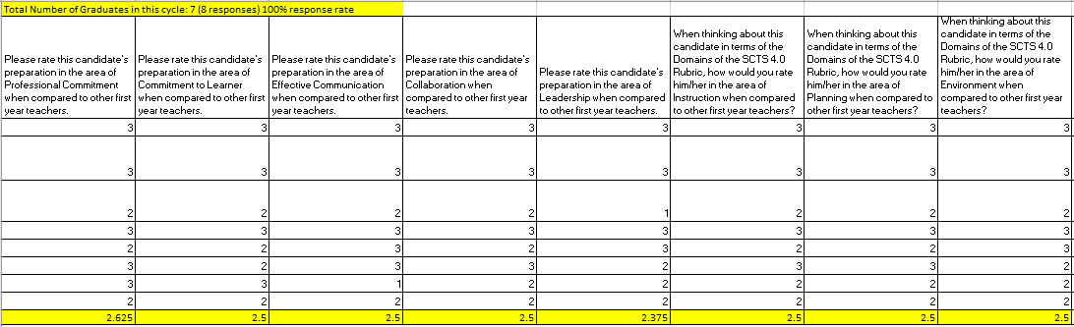

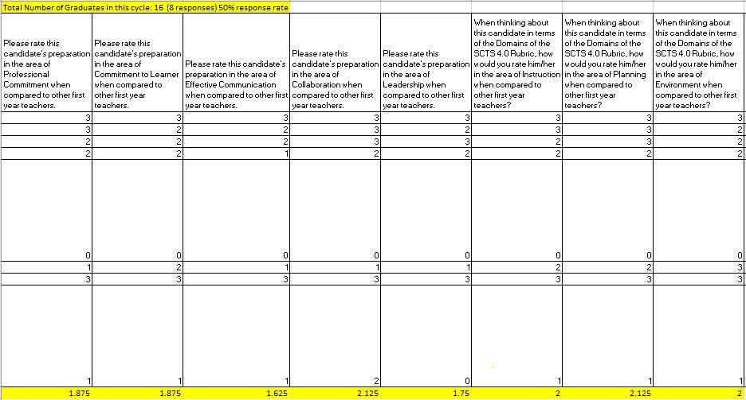

The employer satisfaction data informs the EPP of areas for improvement and areas of strength. Areas for improvement include Effective Communication and Leadership. Areas of strength include Professional Commitment and Collaboration. The EPP continues to explicitly teach, model, and evaluate candidates on these professional dispositions.

Satisfaction of Completers
The Satisfaction of Completers survey is developed and sent out every few years. During the 2020-2021 academic year, the 2018-2019 graduates will be included in the survey.
Completers during the 2017-2018 academic year responded to the EPP Survey. The response rate is 33% (11 out of 33 graduates).
100% indicated a rating of Excellent when asked about their preparation by the EPP in their Program Area.
100% indicated a rating of Excellent when asked about their preparation by the EPP in all three of their Field Experiences.
The EPP recognizes two areas graduates identified with lower ratings. These areas include, working with diverse populations and being prepared with classroom management strategies. 77% indicated a rating of Excellent and 23% indicated a rating of Good when asked about their preparation by the EPP in working with diverse student populations. In the area of Classroom Management, 27% of graduates rated their preparation as Fair, 45.5% as Good, and 27% as Excellent. Both of these areas the EPP seeks ideas continual improvement. The EPP anticipates candidates will need to be more prepared in the area of virtual instruction due to COVID-19.

Graduation Rates
100% of our candidates graduated and completed their certifying program.

Ability of completers to meet licensing and any additional state requirements
100% of our graduates met requirements to pass state licensing exams.

Ability of completers to be hired in education positions for which they have been prepared
90.6% of our 2018-2019 graduates were initially hired to teach in the area in which they were prepared. Of those that did not secure jobs, one is still looking for a job and the other two have decided to wait until the following school year when COVID-19 is not as prominent.

Student loan default rates and other consumer information
The Columbia College Cohort Default Rates were 6.6% (2016), 3.5% (2015), and 4.5% (2014).

